

Ritik Sangwan

*Engineering Student*

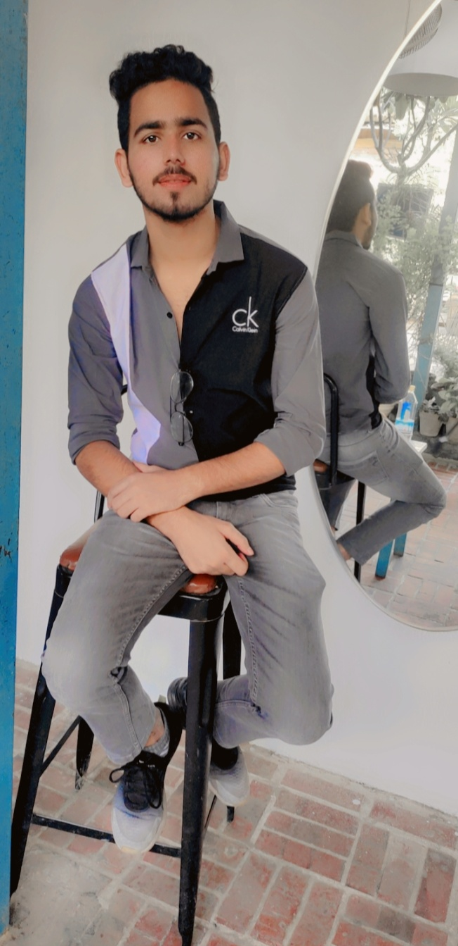**graph**

Ritiksangwan554@gmail.com

+91-6395614302 India

<https://www.linkedin.com/in/ritik-sangwan-634744223/>

# Career Objective- Sample

I am currently a Fresher and like to develop software. I am Interested in problem solving for challenging tasks, and learning new technology and tools If the need arises. Eager to get into Tech Industry and Contribute my Part.

# Technical Skills

Programming Language: C,C++, Python,

HTML,CSS- Tailwind CSS, DSA,REACT

Operating System: Windows,MAC-0S

Database: Oracle, SQL

# Interpersonal Skills (Top 3)- Sample

* Leadership Skills
* Influcencing Skills
* Motivational Skills

# Personal Details

# Date of Birth:16-02-2003

# Father’s Name: Sanjay Sangwan

# Address: Crossing republik,201016

# Language Known: Hindi ,English

# Education

**Bachelor's of Technology | 2020-2024 |** **Computer Science and Engineering (Artificial Intelligence and Machine Learning)**

with 84.17 % Aggregate from ABES ENGINEERING COLLEGE (AKTU)

**Senior Secondary (12th)**

City Vocational Public School, CBSE Board with 93% in 2020

**Secondary (10th)**

City Vocational Public School ,CBSE Board with 86% in 2018

# Projects

**Project 1**

Title: Automatic Attendance System

Technology: Face Recognition System

Description: Automatic attendance done by face recognition or iris it reduce the time and paper.

**Project 2**

Title: Personal Portfolio Website

Technology: HTML, CSS, JAVASCRIPT

Description: An portfolio is a online representation of work you have created , as well as skill and experiences

# Training & Certifications- Sample

* Blockchain Basics by great learning
* PCAP: Programming Essentials in Python

# Co/Extra Curricular Activities-Sample

* Attended a 3 Days workshop on “How one eyed Robot works” by CISCO
* Participated in problem solving with codechef and gfg platform .

# Achievements

* 3 star coder on CodeChef: <https://www.codechef.com/users/ritik_sangwan/>
* 5 star coder on Hackerrank:- <https://www.hackerrank.com/2020B1531020/>
* 500+ problem solved(Leedcode:- <https://leetcode.com/Ritiksangwan/> , GFG:- <https://auth.geeksforgeeks.org/user/ritiksangwan554/practice/> , coding ninja:- <https://www.codingninjas.com/codestudio/profile/Mr_Sangwan/> )

# Hobbies

* Exploring the World
* Gymnastic